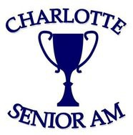

The 9th Annual Charlotte Senior Amateur Championship will take place on Monday-Tuesday, October 26-27, 2026, at Cedarwood Country Club. This tournament will be open to male residents of Mecklenburg County and male members of Mecklenburg County clubs who are age 55 or older as of the tournament date. Competitors must have a handicap index of 9.9 or lower to be eligible to compete. There will be three divisions of competition, one for Seniors (55 & older), Super Seniors (65 & older) and Legends (70 & older). Format: 36 Hole Medal Play. Prizes will be awarded to the low 25% of each division based upon gross scores. Prizes will be in the form of gift certificate money to be used in the golf shop. Applications will open on September 1, 2026, and the entry deadline is October 19, 2026. Tee times are scheduled each day starting on 1 and 10 at 9:00 am.

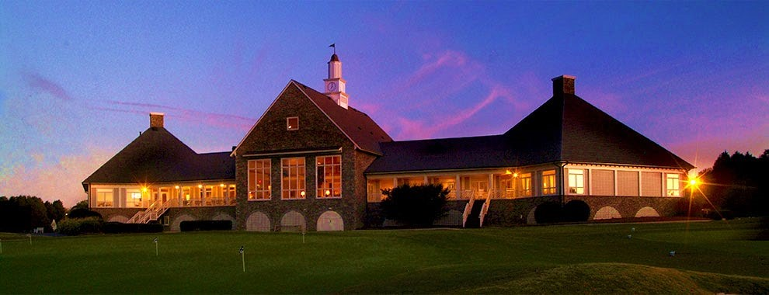
Tournament Dates & Location
Monday-Tuesday, October 26-27, 2026 Cedarwood Country Club

Registration
September 1-October 20, 2026

Divisions
Senior – Ages 55 & Older
Super Senior – Ages 65 & Older
Legends – Ages 70 & Older

Carolinas Golf Association Points
Players are finishing in the Tope 10 are eligible to earn Senior & Super Senior ranking points with the CGA

~ TOURNAMENT HISTORY ~

2025- Cedarwood Country Club
Senior Champion: Neal Morrison 80-75-155
Super Sr Champion: John Rudolph 80-70-150

Legends Champion: Joe Sumrow 77-76-153

2024- Cedarwood Country Club 2023- Cedarwood Country Club
Senior Champion: Steve Harwell 71-73-144 Senior Champion: Dan Hendrickson 76-72-148
Super Sr Champion: James Pearson 76-71-147 Super Sr Champion: John Rudolph 79-70-149
Legends Champion: John Fritz 70-74-144 Legends Champion: Greg Powell 80-73-153

2022- Cedarwood Country Club 2021- Cedarwood Country Club
Senior Champion: George Harris 73-78-151 Senior Champion: Steve Harwell 69-76-145
Super Sr Champion: Jim Gallagher 76-75-151 Super Sr Champion: Noel Brown 80-75-155
Legends Champion: Jerry Hartsell 71-75-146 Legends Champion: Dave Moser 75-79-154

2019 – Cedarwood Country Club 2018 – Carmel Country Club
Senior Champion: Kelly Stimart 72-68-140 Senior Champion: Gary Brown 74-71-145
Super Sr Champion: Noel Brown 75-76-151 Super Sr Champion: Rick Kline 73-75-148

2017 – Charlotte Country Club 2016 – Myers Park Country Club
Senior Champion: Johnny Elam 73-65-138 Senior Champion: John Rudolph 71-73-144
Super Sr Champion: Garrett Garland 74-72-146 Super Sr Champion: Garrett Garland 71-71-142

